Program Implementing Regular Expression

#!/usr/bin/perl -w
#Tells the computer we are using the perl interpreter.

print "1.The variable value is 'Hello World'.We are searching if there is any number";
$var="Hello World";

#Here the program searches the whole string for atleast one occurence

if($var=~ /[0-9]/){
print "\n\tAns)Yes, the characters are present\n\n";
}
else{
print "\n\tAns)No, the characters are not present\n\n";
}

print "2.The variable value is 'Hello1 World'.We are searching if there is any number";
$var="Hello1 World";
if($var=~ /[0-9]/){
print "\n\tAns)Yes, the characters are present\n\n";
}
else{
print "\n\tAns)No, the characters are not present\n\n";
}

#Here program searches for a whole string of a particular term when we know what we are searching for

print "3.The variable value is 'Hello World'.We are searching if there is a word perl in the variable";
$var="Hello World";
if($var=~ /^perl$/){
print "\n\tAns)Yes, the characters are present\n\n";
}
else{
print "\n\tAns)No, the characters are not present\n\n";
}

print "4.The variable value is 'Hello World in Perl'.We are searching if there is a word perl in the variable";
$var="Hello World in Perl";
if($var=~ /Perl/){
print "\n\tAns)Yes, the characters are present\n\n";
}
else{
print "\n\tAns)No, the characters are not present\n\n";
}

#Here program searches for a loosely defined pattern. Useful as in cases like validating email.

print "4.The variable value is 'krishnanunnir97\@gmail.com'.We are searching if there is a word perl in the variable";
$var="krishnanunnir97\@gmail.com";
if($var=~ /^[a-z0-9]*\@[a-z]*\.[a-z]*$/){
print "\n\tAns)Yes, the characters are present\n\n";
}
else{
print "\n\tAns)No, the characters are not present\n\n";
}

print "Here we are applying the earlier test but with the variable 'krishnanunnir97\@gmail.8com'";
$var="krishnanunnir97\@gmail.8com";
if($var=~ /^[a-z0-9]*\@[a-z]*\.[a-z]*$/){
print "\n\tAns)Yes, the characters are present\n\n";
}
else{
print "\n\tAns)No, the characters are not present\n\n";
}

OUTPUT

1.The variable value is 'Hello World'.We are searching if there is any number
Ans)No, the characters are not present

2.The variable value is 'Hello1 World'.We are searching if there is any number
Ans)Yes, the characters are present

3.The variable value is 'Hello World'.We are searching if there is a word perl in the variable
Ans)No, the characters are not present

4.The variable value is 'Hello World in Perl'.We are searching if there is a word perl in the variable
Ans)Yes, the characters are present

4.The variable value is 'krishnanunnir97@gmail.com'.We are searching if there is a word perl in the variable
Ans)Yes, the characters are present

Here we are applying the earlier test but with the variable 'krishnanunnir97@gmail.8com'
Ans)Yes, the characters are present

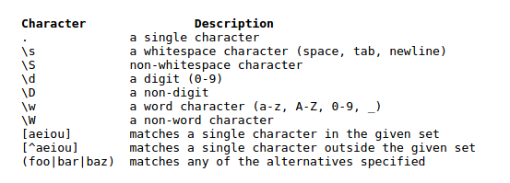
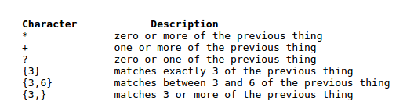
Text Processing

Substitute Regular Expression - s///
Transliterate Regular Expression - tr///
#/user/bin/perl -w
$var = "The cat ate all the food";
#Modifing each occurence of cat with dog using s///
$var =~ s/cat/dog/;
print "The modified string is $var\n";
#Changing the whole sentence into Uppercase using tr///
$var =~ tr/a-z/A-Z/;
print "The capitalized string is $var\n";

OUPUT

The modified string is The dog ate all the food
The capitalized string is THE DOG ATE ALL THE FOOD

